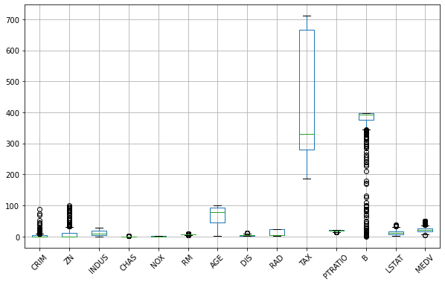

Box plot to identify the outliers

  
Remove outliers



Impute missing values(Replaced with mean)

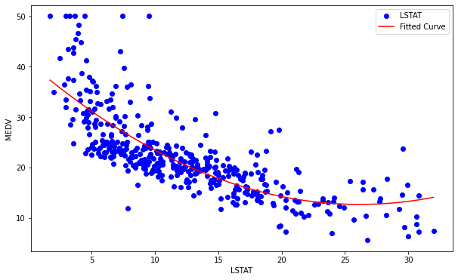

Scatter plot and fitted curves for LSTAT

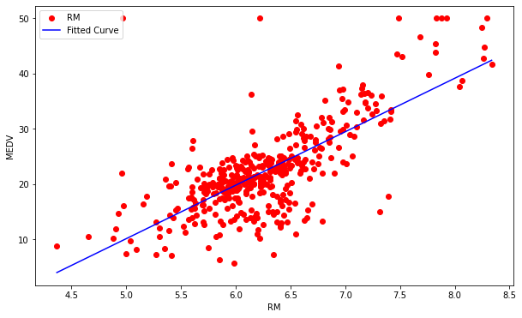

Scatter plot and fitted curves for RM



Calculate the Pearson correlation coefficient